4.9 Newton’s Method Worksheet

- Approximate to four decimal places.

Let therefore and . We make our initial guess based on the fact that . So we guess that .

- Approximate to four decimal places.

Let therefore and . We make our initial guess based on the fact that . So we guess that .

- Approximate to five decimal places.

Let therefore and . We make our initial guess based on the fact that and . So we guess that .

- Find all solutions of the equation (up to six decimal places).
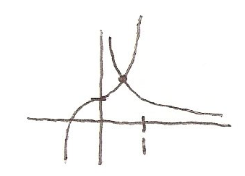
By graphing these functions we see that they only have one intersection.

Let . Then .
We make our initial guess less than 1. Suppose we choose .

- Consider the function .

- Show that Newton’s Method does not find a root if . What does the sequence of approximation do here? Round decimals to six places.

If we look carefully we can see that this sequence of approximations appears to be looping.

- Show that Newton’s Method can find a root if . Find the root accurate to six places.

- What do parts (a) and (b) tell you about the selection of ?

This tells us that our guess for is important and we must try to have an initial value that is close to the root we are trying to approximate.

